Divergence in the ecological space between cryptic blue mussel species in the White Sea: towards to species distribution modelling
Assessment of ecological niche divergenccy between blue mussels Mytilus edulis L. and M. trossulus Gould in the White Sea using SDM approach

V. M. Khaitov, A. A. Zaychikova, P. Y. Safonov, M. V. Katolikova, M. V. Ivanov, P. P. Strelkov

Introduction
Species distribution models (SDMs) being a numerical tools describing the relationship between species occurrence and environmental parameters allow to predict distribution patterns of species both in space and time (Elith, Leathwick, 2009). SDMs are also considered as a formal way of species’ ecological niche assessment (Elith, Leathwick, 2009). When the SDMs are jointly applied to a number of coexisting species, i.e. community, it allows to describe the ecological niches partitioning between species (an approach sometimes referred to as Joint Species Distribution Modelling, JSDM, Ovaskainen, Abreg, 2020). SDM/JSDM thus describe how environmental conditions and biological interactions surroundings affect the presence (or abundance) of a species, and allow us to predict under what conditions the presence of the species can be expected.) In other words, the SDM can answer the question along which axes in ecological space coexisting species are segregated, occupying different niches. The range of approaches to building SDM is very wide: from regular multiple regressions up to advanced machine learning methods (+++). In particular, GAM (generalized additive model, Wood, 2017), which being a flexible tool can reveal curvilinear dependences ++++ , is well suited for SDM construction (Elith et al., 2006).
SDMs are mostly applied for «good», morphologically distinct species (e.g. Reiss et al., 2011; Lindegren et al., 2022) that can be easily involved in routine studies requiring numerous samples. Increasing evidence for coexisting cryptic species (Bastrop et al 1998; Fiser et al 2010) as well as infraspecific taxa within polytypic species (i.e. subspecies, phylogenetic lineages) (++++REF) raises the question of distinctions in their ecological traits, in particular how they share space and resources in sympatry. Since it is unlikely that any coexisting taxa have identical ecological phenotypes, there must be ecological niche partitioning between them, a question that can be answered using SDM/JSDM modeling. Strictly speaking, when applying SDM/JSDM modeling to such cases, we consider coexisting cryptic taxa as a community. In marine ecology, only a few studies in this direction have been conducted so far (Lowen et al 2019; Dennis, Hellberg, 2010).
/The SDM framework is long used in terrestrial ecology (+++) but the amount of papers employing such technique for marine species has been increasing in recent years as well (Robinson et al 2017+ современная ссылка). SDMs in marine ecology are mostly applied for «good», morphologically distinct species (e.g. Reiss et al., 2011; Lindegren et al., 2022) that can be involved in routine studies which require numerous samples. The growing evidence for cryptic species (Bastrop et al 1998; Fiser et al 2010) and polytypic species (++++REF) among marine animals makes it relevant to search for approaches to analyse their distribution in the case of their sympatric coexistence. The SDM framework seems to be well suited to answer the question of which axes in eclogical space are common for coexisting cryptic species, and along which axes they diverge, occupying different ecological niches. Strictly speaking, by building a distribution model of cryptic species in sympatry, we are describing something like a community and in this sense we come close to the JSDM paradigm. Only few studies have been conducted in this direction in the marine ecology so far (Lowen et al 2019; Dennis, Hellberg, 2010)./
In the marine realm, the blue mussel Mytilus edulis complex is the longest scientifically known and best-studied group complex of cryptic species (Knowlton 1993, ++++???). It includes several species that are more easily distinguished genetically than morphologically and have the ability to hybridize in sympatry (++++++). Blue mussels are powerful ecosystem engineers in the temperate and subpolar seas playing an important role in coastal communities (+++). They are also important objects of aquaculture (+++). In the North Atlantic, the dominant species are M. edulis (thereafter ME) and M. trossulus (MT), which form zones of sympatry (thereafter contact zones) in different corners of the region from Scotland and the Gulf of Maine in the south to Greenland and Svalbard in the north (Wenne et al. 2020 and references therein). In contact zones, ME, MT and their hybrids are often found in the same samples from mussel settlements; such settlements are hereafter referred to as “mixed”. Scientists generally agree that ME and MT are ecologically distinct in sympatry (++++ RC, Katolikova et al.) and have different economic value in aquaculture (+++), but the data on the factors of their ecological segregation i.e. ecological niche partitioning, is fragmentary and contradictory.
On a biogeographic scale, the distribution of Mytilus species is thought to be regulated primarily by temperature and its correlates (Hayhurst, Rawson, 2009; Wenne et al., 2020). Both species occur in the Arctic, e.g. on Spitzbergen but MT does not penetrate as far south into temperate/boreal seas as ME (Wenne et al., 2020), appearing to be a more stenothermic, cold-loving species.
The greatest progress in comparative ecological studies of ME and MT in sympatry has been made in the contact zones in the Baltic Sea, in the waters of the Kola Peninsula (White and Barents Seas) and in the West Atlantic (mainly, Gulf of Maine and New Scotland). In the Baltic Sea, the brackish areas of the inner part of the sea are inhabited only by MT, while the saltier areas closer to the North Sea are inhabited by ME. In the middle runs the contact zone, where mixed settlements are often dominated by hybrids, and MT gene frequency gradually? increases towards the inner Baltic (VS 11, Zbawicka et al. 2014, Stuckas et al. 2017). As a result, species distribution is strongly correlated with salinity, against which the role of other factors is negligible (++++).
In the Kola and West Atlantic zones the situation differs from that in the Baltic. Hybrids are always in the minority (less than 20%) in mixed settlements (Wenne et al. 2020; Katolikova et al. 2016). Species are distributed in space in a mosaic fashion, both in regional and local scales (RC, +++++ ). The relationship between distribution of species and salinity is nowhere obvious (RC 05, Katolikova et al. 2016; Wenne et al. 2020, Marchenko et al. 2023), but a number of other factors of ecological segregation have been proposed. Against the background of the observed mosaic, the relation to salinity is not obvious (+++ RC 05). Some correlation of MT proportion with distance to the river’s mouth could be found but no direct evidences of salinity role was provided (Marchenko et al. 2023). In contrast to salinity, a number of other factors of ecological segregation have been proposed for these contact zones.
In the White and Barents Seas, the frequency of MT is elevated in port areas, possibly due to recent introduction of this species into the region in historic times with ship traffic (VS11, Katolikova et al. 2016). The only one factor of species segregation explicitly tested in the White Sea was the substrate to which littoral mussels attach (Katolikova et al. 2016). It turned out that MT is more common on fucoid algae while ME mostly lives directly on the bottom (mud, sand, stones, gravel). The non-random distribution segregation of species across substrates, however, cannot explain the entire local-scale mosaic in their distribution (Katolikova et al. 2016). Parallel studies in the Barents Sea did not consider mussel substrates, but verified the hypotheses of non-random distribution of species with depth. Parallel studies in the Barents Sea did not consider mussel substrates, but confirmed the hypothesis of different depth preferences of species. It turned out that on vertical transects, the proportion of ME increases with depth and, as a result, MT appears to be a more littoral species and ME a more sublittoral one (Marchenko et al. 2023). In the western Atlantic, depth, level of anthropogenic pollution and surf exposure has been considered as possible factors in species segregation (++++), but none of these hypotheses have been tested on sufficient material.
It was hypothesized that MT may be more abundant than ME in littoral (Marchenko et al. 2023), polluted (++++), and surf-exposed habitats (+++), but none of these hypotheses have been tested on sufficient material.
Summarizing the above, To sum up, in the non-Baltic MT-ME contact zones no simple, “single-factor” pattern of species distribution along most candidate ecological gradients was revealed and some candidate factors involved into analysis were potentially collinear, masking each other. For example, ports are often located in storm-protected areas, usually in estuaries. This makes it difficult to isolate the effects of shipping (and other anthropogenic factors), surf and salinity. The same could be said about the effects of depth and fouling substrate since the littoral fucoids are rare in the sublittoral where they are replaced by kelp forests (REF).
This state of knowledge is not surprising given that for most of the time of blue mussel research, scientists have used labor-intensive genotyping methods to identify cryptic species and therefore have been unable to precede could not handle the large amount of material (Khaitov et al., 2021). In addition, until recently there were no reliable statistical methods available to model the distribution of sympatric taxa in the space of multiple factors, i.e. no SDM/JSDM approach was realized. To our knowledge, in the history of ME and MT studies the SDM this approach have been applied only twice, by Kijewski et al.(+++) and by Wenne et al. (+++). Both times the machine learning techniques were used to model the macro-geographic distribution of species (technically, of allele frequencies at taxonomically informative genes) in the space of multiple climatic and oceanographic characteristics available from public databases. The conclusions of these studies are summarized by recognizing temperature and salinity as important factors influencing the geographical distribution with MT tolerate lower salinities and temperatures than ME (Kijewski et al. +++ Wenne et al. +++, see also above).
Finding a simple semi-diagnostic shell trait for ME and MT - the presence or absence of a continuous uninterrupted prismatic strip under the ligament on the inner side of the shell (Zolotarev +++, Katolikova et al. 2016), allowed us to reliably interpret the taxonomic structure of their mixed settlements without genotyping. In the White Sea 74% of MT, but only 4% of ME have the strip (Katolikova et al., 2016), and using the regression models the frequencies of shell morphotypes in samples can be recalculated into proportion of MT in samples (thereafter Ptros, see equations in Khaitov et al., 2021). Note that hybrids are not considered as separate category under this approach.
The goal of our study was to estimate the divergence of ecological niches between ME and MT in the White Sea littoral along such environmental gradients as substrate of fouling, salinity, surf level, and distance from ports . All these factors have been proposed in previous studies as candidate factors of segregation of species in sympatry (REF). The last of the previously suggested factors, depth (RC05, Marchenko et al. 2023), was not studied by us, but was controlled by sampling at the same littoral level. To achieve the goal, we used the morphological method to estimate Ptros in 570 mussel samples from sites with known environmental characteristics all over the Bay, and SDM to estimate the partial effect of these predictors on the distribution of Ptros. Since all predictors were included in one single GSM model, this avoided doubts related to the collinearity between them. Ideally, a model trained on reliable data should allow the prediction Ptros in independent data, and we evaluated its predictive power using independent testing datasets from the White and Barents Seas. We also attempted to answer the question whether the pattern of species segregation by substrate is density-dependent. For example, if there is dependence, segregation may be a consequence of competition between species. Conversely, if segregation is independent of density, it may reflect differences in the “fundamental niches” of species.
The use of such extensive data allows the construction of an SDM describing Ptros variation from which two outcomes are expected. First, the model will allow us to accurately assess the relationship between the taxonomic composition of mixed mussel assemblages and environmental factors. Second, it will allow to predict in which conditions populations can be expected to be dominated by ME (low Ptros) and where we should expect elevated concentrations of MT (high Ptros).
In this study, we will construct a model that will describe the relationship between the proportion of MT (Ptros) in a settlement in the Kandalaksha Bay of the White Sea and four groups of predictors that where considered in the previous works as the most significant environmental gradients regulating species distribution in sympatry (substrate, salinity, proximity to ports and surf level). We will include all the predictors in one model simultaneously to avoid doubts about their collinearity. We will also look in more detail at the influence of substrate type as a possible factor in species segregation. The last of the previously discussed factors, depth, was not studied by us, but was controlled by sampling at the same littoral level. By this way we hope to assess which factors govern the composition of mixed settlements in contact zones and therefore obtain the first type of outcome from SDM (see above). To assess the ability of the model constructed to predict Ptros values (the second SDM outcome) we will use test material collected from both the White Sea and neighboring Barents Sea contact zones.

Material and methods

Material and methods
Study area
The study area was Kandalaksha Bay, where all previous ME and MT studies in the White Sea have been conducted (REF). The 185 km long Kandalaksha Bay is funnel-shaped with numerous islands and skerries and highly indented coastline (Fig. 1). Climate is continental subarctic with 4-5 months of ice cover and the average monthly sea surface temperature in August of 13.8°C. Mean tidal range is about 2 m. Summer surface salinity is 24-25 ppt throughout most of the Bay, but is lower in the estuarine areas (++++).Two hydropower plant’s canals and сколько? rivers with a catchment area of 141 - 12830 km² (see Stable ++ ) flow into the Bay, with the largest river, the Niva, entering the Bay at its very top. Due to the complex geometry of the shoreline and numerous rivers, local surf and salinity gradients are pronounced (Filatov et al., 2005).
Historically (through the 20th century), six ports were functioning in the area operating oceanic vessels (Fig. 1). Two of these ports, historically the biggest ones, both in the top of the Bay, are still functioning while the remaining are abandoned (Sailing directions of the White Sea, 1932; Krasavtsev, 2011) but still visited by small ships, according to the common knowledge.
Mussels are ubiquitous in the littoral zone of the Bay. They are particularly abundant in the fucoid algal belt (mainly Fucus vesiculosus and Ascophyllum nodosum), which is continuous 0.5-1.0 m above mean spring tide depth (Berger et al. 2001). According to data from 2002–2013, both mussel species were almost ubiquitous in the Bay, but their ratio in settlements varied greatly and ME was generally dominant (Katolikova et al. 2016).

Modelling data set
Mussel sampling and processing
Between 2011 and 2018, mussels were sampled at 95 sites within the littoral fucoid belt. (materials from 17 sites was published previously as S2 Table Data for 17 sites were included in the study by Katolikova et al. 2016, the remaining data are new. Sites were chosen to describe littoral populations in of the Bay in as much detail as possible and to account for the heterogeneity of their habitat by substrate type, surf level, and distance from rivers and harbors. in terms of substrate type, surf exposure, and distance from rivers and harbors. All samples were taken in the middle part of within the fucoid belt to minimize differences in depth. At each site, three samples from fucoid thalluses (hereinafter, Algal samples) and three samples from bottom substrates (Bottom samples) were collected in few meters from each other using 0.25 m² and 0.025 m² frames respectively. In all cases frame was placed on the bottom area where mussels’ aggregations were visually recognized. When sampling, the frames were not placed randomly, but in such a way as to capture the densest mussel aggregations.
In all samples only mussels with shell size more 10 mm were involved in further analysis. The processing of mussels collected from different substrates was differently organized. From the Bottom samples all mussels were selected. From Algal samples, one bundle of algae (selected so that to contain some dozens of mussels) was taken from the frame and weighted along with attached mussels. The remain algae were taken from the frame and weighed by the same manner (i.e with attached mussels). Only mussels from the bundle selected were used in further analysis. To assess the total number of mussels in the Algae sample, the weight of the bundle with the known number of mussels and the weight of the algae rest in the frame were compared. For 12 sites the information on abundance of mussels in algal samples was lacking, and these sites were excluded from those analyses which required this data.
Because shell morphotypes can be reliably identified in mussels larger than 10 mm (Khaitov et al. 2021), only such mussels were selected from samples and used in further analyses. The procedure for selection of mussels from samples taken from different substrates was different. From the bottom samples, all mussels were selected. From algal samples, one bunch of algae (selected so that to contain few dozens of mussels), and all other algae were weighed separately, along with attached mussels. Only mussels from the bundle were used in further analysis. To predict the total number of mussels in the sample, the weight of the bundle with the known number of mussels and the rest of the algae was compared. For 12 sites the information on number of mussels in algal samples was lacking, and these sites were excluded from those analyses which required data on mussel abundance.
Shell morphotypes (E-morphotype, characteristic to ME, and T-morphotype, characteristic to MT) were identified for all mussels selected from samples as in Khaitov et al. (2021). As a result, the abundance of mussels density of mussels of different morphotypes with shell length >10 mm was known for each sample. For further, the proportion of T-morphotypes (PT) was converted to the proportion of MT (Ptros) in each individual sample, in pooled total samples from one each substrate type in a site (Ptros_{Alge} and Ptros_{Bottom}) and in pooled samples from each site in total (Ptros_{Site} ) using the Equation 1 from in Khaitov et al. 2021.
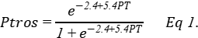
Shell morphotypes were identified for all selected mussels as in Khaitov et al. (2021). As a result, the density of mussels of different morphotypes with shell length >10 mm square meter was known for each sample. For further, the proportion of morphotypes was converted, using Equation 1 in Khaitov et al. 2021, to the proportion of MT (Ptros) in each sample, in pooled samples from each substrate in a site (PtrosAlge and PtrosBottom) and in pooled samples from each site (PtrosSite).
Environmental parameters assessment
In total, we used seven parameters describing possible influence of rivers, ports, surf and type of substrate on mussels. The list of parameters and their description is provided in Table ++. We used three different proxies of salinity (RiverSize, DistRiver and Salinity), believing that a single estimate of salinity at low tide could be insufficient to characterize overall salinity, and river influence per se at the sampling sites. Salinity was measured directly with accuracy of 1 ppm using an “Atago S/Mill-E” refractometer. To classify rivers by size (RiverSize), the data from the ESM +++ was used. To calculate Fetch, the R-package “windfetch” (Seers, 2022) was applied to regional geographic map shape-files.
Table ++. Environmental parameters used for the analysis
Environmental parameters studied
Environmental parameter/ model predictor | Type | Explanation | Range (median) in the data
Influence of substrate
Substrate | Categorical | Algal and Bottom samples for each site are treated separately | Algae VS Bottom
Influence of rivers
Salinity | Continuous | Surface salinity (ppm ppt) at the time of sampling, i.e. at low tide. | 2-30 (19)
DistRiver | Continuous | The straight line distance (km) between the site and the nearest river mouth by map. The values were log-transformed when used for model fitting. | 0-18.5 (4.9)
RiverSize | Categorical | Rivers are categorized according to whether their catchment area is larger or smaller than the median area of all rivers in the region. | Small VS Large
Influence of ports
DistPort | Continuous | The straight line distance (km) between the site and the nearest port by map. Log-transformed values were used. | 0.1-82.2 (18.7)
PortStatus | Categorical | Ports are categorized according whether they are active or abandoned | Active VS Abandoned
Influence of surf
Fetch | Continuous | Unobstructed length of water surface (km) over which wind from a certain direction can blow over. Log-transformed values were used. | 0.2-28.8 (3.3)

Testing datasets
Three datasets were used as testing ones. The first included mussel samples from 12 sites from the same areas of Kandalaksha Bay (STable ++, SFig. 1 B). At 4 sites only Bottom and at 4 sites only Algae samples were collected with several СКОЛЬКО БЛЯДЬ? replications, at 4 sites we collected both Algae and Bottoms substrates but with lesser replications СКОЛЬКО БЛЯДЬ? in comparison with the modelling data set – УЖЕ СКАЗАЛ СКОЛЬКО ТАМ БЫЛО (in total 16 units – ЧЕГО ЮНИТС? were used). All other procedures were the same as in case of main dataset. ЗА МЕСЯЦ ПЕРЕСОБРАЛ ЧТО ЛИ? БЫЛО - The first included mussel samples from 23 sites from the same areas of Kandalaksha Bay (STable ++, SFig. 1 B). At each site only Bottom or only Algae samples were collected while all other procedures were the same as in case of main dataset.
Testing datasets
Three datasets were used as testing ones. The “Kanalaksha littoral” included 23 samples from 12 littoral sites in Kandalaksha Bay. At four sites only Algal samples were taken, at four - only Bottom ones, and at the rest four - from both substrates (STable ++, SFig. 1 B). Environmental parameters were assessed in the same way as for the modeling dataset.
The second and third testing datasets were extracted from the published data of Marchenko et al. 2023. These authors mapped in detail the distribution of Ptros in mussel settlements of Tyuva Inlet in the Kola Bay of the Barents Sea in 2009-2010 and provided for each sampling site a number of environmental characteristics including depth, Salinity, cover abundance of macrophytes by rank scale, and dominant algal species (usually, kelps in the sublittoral and fucoids on the littoral). From these data we extracted two datasets, “Tyuva littoral” and “Tyuva sublittoral”. The first set included all ?? samples from all 23 studied littoral sites from the depth range corresponding to the fucoid belt (0.5-1.5 m above mean spring tidal depth, Marchenko et al. 2023; note that the tidal amplitude is larger in the Barents Sea than in the White Sea). The second included all ?? samples from all 15 studied sublittoral sites (depth range -0.5 - -3.5? m). Since the substrate of mussel fouling was not controlled during sampling, we classified samples into Bottom and Algal ones by the algal cover in studied sites (ranks 1-3 and 4-5, correspondingly). The remaining environmental parameters were predicted as for the modeling dataset, with the nearest port in Ekaterininskaya Gavan Bight considered as active and the river Tyuva flowing into Inlet (catchment area 351 kmІ) as a large one.
Statistical analysis
All processing was performed using the statistical programming language R 4.05 (R core Team, 2021)
Dependency of Ptros on environmental parameters predictors in modelling dataset
Assuming that the relationship between the dependent variable (Ptros) and continuous predictors can be curvilinear (Austin, 2002), we used GAM (generalised additive model, Wood, 2017) as a modelling technique that has worked well for SDM construction (Elith et al., 2006). The GAM fitted (thereafter Model 1) was based on beta-binomial residuals distribution and the restricted maximum likelihood (REML) method for parameters estimation. Smoothers for all continuous predictors were fitted using cubic basic splines. Categorical predictors were included as parametric terms in the model. “Site” was considered as random factor in the Model 1. The function gam() from the package “mgcv” (Wood 2017) was used to fit the model.
To check for the predictors’ collinearaity collinearity in the model we calculated the variance inflation factor (VIF, Fox & Monette, 1992). Additionally we calculated Pearson correlation between continuous predictors. To verify that the Model 1 meet the assumptions of sampling independence, we examined the presence of residuals’ spatial autocorrelation by means of spline correlogram construction (Bjornstad, Falck, 2001) with the function spline.correlog() from the package “ncf” (Bjornstad, 2022). No evidences of spatial autocorrelation were revealed for the Model 1.

Association between Ptros, subtrate types and mussel abundance
For a more deep analysis of association between Ptros and substrate type we calculated the difference (Dif) between Ptros_{Algae} and Ptros_{Bottom} for each site. For each site we calculated the difference between proportion of MT in Algal and Bottom samples: Dif = PtrosAlgae - PtrosBottom. The obtained Dif values were used as dependent variable in the Model 2 which was constructed as GAM with gaussian residuals’ distribution. The proportion of MT in site (Ptros_{Site}) and the mean mussel’s abundance 1 m² (MeanN) were used as predictors in Model 2. We used function gam() from the package “mgcv” for the model construction.

Assessment of the model 1 predictive power
To assess ability of Model 1 to predict the MT-ME distribution Ptros we used three data sets: (1) main modelling dataset (the data used for Model 1 construction), (2) testing dataset from the Kandalaksha bay, (3) the first part of testing dataset from the Tyuva bay, i.e. data collected from fucoid’s belt and (4) the second part of data from the Tyuva inlet, i.e. sites out of fucoid’s belt.
To assess the Model 1 predictive power All sites included in the analysis within the modeling and each of three testing data sets were divided into two groups MT-dominated (PtrosSite > 0.5) and ME-dominated (PtrosSite < 0.5) ones. Using the parameters of Model 1 we calculated predictions of the model both for the modelling and each of the testing datasets. Thereafter the predicted values were considered as classifiers for detecting MT- or ME-dominated groups sites. The receiver operated characteristics (ROC) followed by analyzing the area under curve (AUC, Fielding, Bell,1997; Fawcett, 2006) was used to evaluate models performance. The function roc() from the package “pROC” (Xavier et al. 2011) was used.

Results
Environmental parameters in the Kandalaksha Bay
Against a background of high mosaicity in distribution of Salinity and Fetch values, the most wind exposed sites were located on the northeastern coast of the Bay, and on the open shores of the islands in its top (Fig. 1 A) while the most desalinated areas - in the very top of the Bay (Fig. 1 B). Expectedly, Salinity tended to decrease towards river mouths (SFig. ++ D) and was lower closer to large rivers than to small ones (SFig. ++ D). Sites located close to ports tended to have lower Fetch (SFig. +++ F) but no association between DistPort and Salinily was found (SFig. +++ E). All correlations between Salinity, DistRiver, DistPort and Fetch were rather low (STable +++) with maximum correlation between Fetch and DistPort (r = ++).

Two of six ports presented in the area were active at the date of material collection (Fig. 1 A, STable ++ SEM). The most exposed sites (maximum values of Fetch wind fetch) were located on the western coast of the Kandalaksha Bay, and on the open shores of the islands at the top of the bay (Fig. 1 A). The most desalinated areas were the top of the Bay and inlets where rivers flow into (Fig. 1 A). Salinity at sites situated close to “Large” rivers was lower than at sites closer to “Small” ones (SFig. ++, C). Salinity tended to increase with increasing of distance to the mouth of the nearest river (SFig. ++ D) but no association between distance to the nearest port and salinity was found (SFig. +++ E). Sites situated close to ports tended to have lower wind fetch (SFig. +++ F). All correlations between salinity, distance to the nearest river mouth, distance to the nearest port and wind fetch were rather low (STable +++). The largest correlation revealed was between wind fetch and distance to nearest port (r = ++).
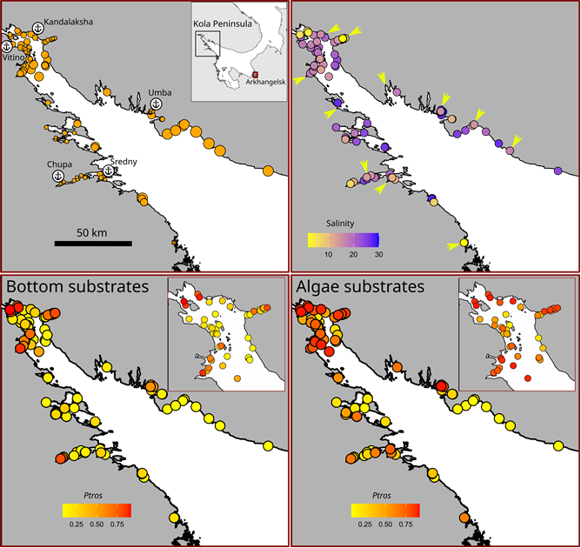
Figure +. Taxonomic structure of mussel settlements and their habitat characteristics. (A) The map of Northern Europe. Box indicates the location of the. Kandalaksha Bay, arrow indicates the location of Tyuva Inlet. B) Surf conditions in the sampling sites. Point filling is proportional to Fetch value. (C) Salinity conditions in the sampling sites. Point filling is proportional to Salinity. Arrows mark the mouths of large rivers. (D-G) Proportion of MT in pooled? Bottom (D-E) and Algae (F-G) samples from sampling sites. Point filling is proportional to Ptros. E and G show the top of the bay in higher resolution. Anchor marks with port names on B-F indicate the harbors. Names of abandoned ports are marked by asterisks.
Ptros spatial distribution in the Kandalaksha Bay
The maximum Ptros was observed in the top of the Kandalaksha Bay itself and in the small bays deeping into the mainland (Fig. +, C, D). At the same time, sites with a lower Ptros were located in the immediate vicinity of sites where high Ptros values were represented (Fig. +, C, D), reflecting the high variation of taxonomical structure in small spatial scale. Settlements with the lowest Ptros both in Bottom and Algae samples were represented in the open parts of the North-West coast.
On the background of strong correlation between Ptros on two substrates between sites, increased Ptros in Algal samples than in Bottom ones is universally striking (Fig. +). Against a background of high spatial mosaicity in the distribution of Ptros, its maximum values on both substrates were observed in the upper part of the Bay and in some inlets deep into the shore, while its minimum values - along the open part of the northeastern coast (Fig. +). Correlations between Ptros and other environmental characteristics but substrate are difficult to discern on the maps (Fig. +).
Relationship of Ptros to environmental parameters
The values of VIF calculated for the predictors’ set included in the analysis were rather small (the maximal VIF was detected for Fetch: 1.76). Although some pairwise correlation between environmental factors were found (see above) the low VIF values (the maximal VIF was detected for Fetch 1.76) can be interpreted as a negligible collinearity between predictors (i.e. they don’t mask influence of each for other).
To assess the dependency of Ptros on all predictors considered we constructed the Model 1 (Table +, R² = 0.71) which explained 77% of total deviance. The Model 1 revealed statistically significant dependency of Ptros on all predictors except one (table ?). The effective degrees of freedom (edf, Table ++) for most smoothers were close to 1, reflecting the linear dependence of Ptros on such continuous predictors as distance to the nearest port (DistPort) and fetch (Fetch). The exception was Salinity, where a pronounced curvilinear dependence was revealed.
Although some non-zero pairwise correlations between environmental factors were found (see above) the low VIF values calculated for the predictors (the maximal VIF was for Fetch, 1.76) can be interpreted as a negligible collinearity between them, i.e. predictors did not mask influence of each other.
The Model 1 which explained 77% of total deviance, revealed significant dependency of Ptros on all predictors except DistRiver. The effective degrees of freedom close for 1 for DistPort and Fetch indicates the linear dependence of Ptros on these predictors. On the contrary, a pronounced curvilinear dependence on the third continuous predictor, Salinity, was revealed (Table ?).

Table 1 . Parameters of smoothers and coefficients of parametric terms for the Model describing dependency of Ptros on predictors. Edf stands for the effective degrees of freedom
Smoother terms | edf | ref.edf | Chi.sq | p-value
s(Salinity) | 2.4 | 9 | 396.7 | 0.0033
s(DistRiver) | 0.0 | 9 | 0.0 | 0.6724
s(Fetch) | 0.9 | 9 | 88.2 | 0.0417
s(DistPort) | 1.0 | 9 | 276.2 | 0.0016
Random effect s(Site) | 74.4 | 92 | 453.6 | 0.0000
Parametric terms | Parameter estimate | SE | z-statistic | p-value
(Intercept) | -1.7 | 0.1 | -11.8 | 0.0000
Substrate(Algae) | 0.9 | 0.1 | 14.6 | 0.0000
RiverSize(Large) | 0.4 | 0.2 | 2.6 | 0.0091
PortStatus(Active) | 1.0 | 0.2 | 5.7 | 0.0000
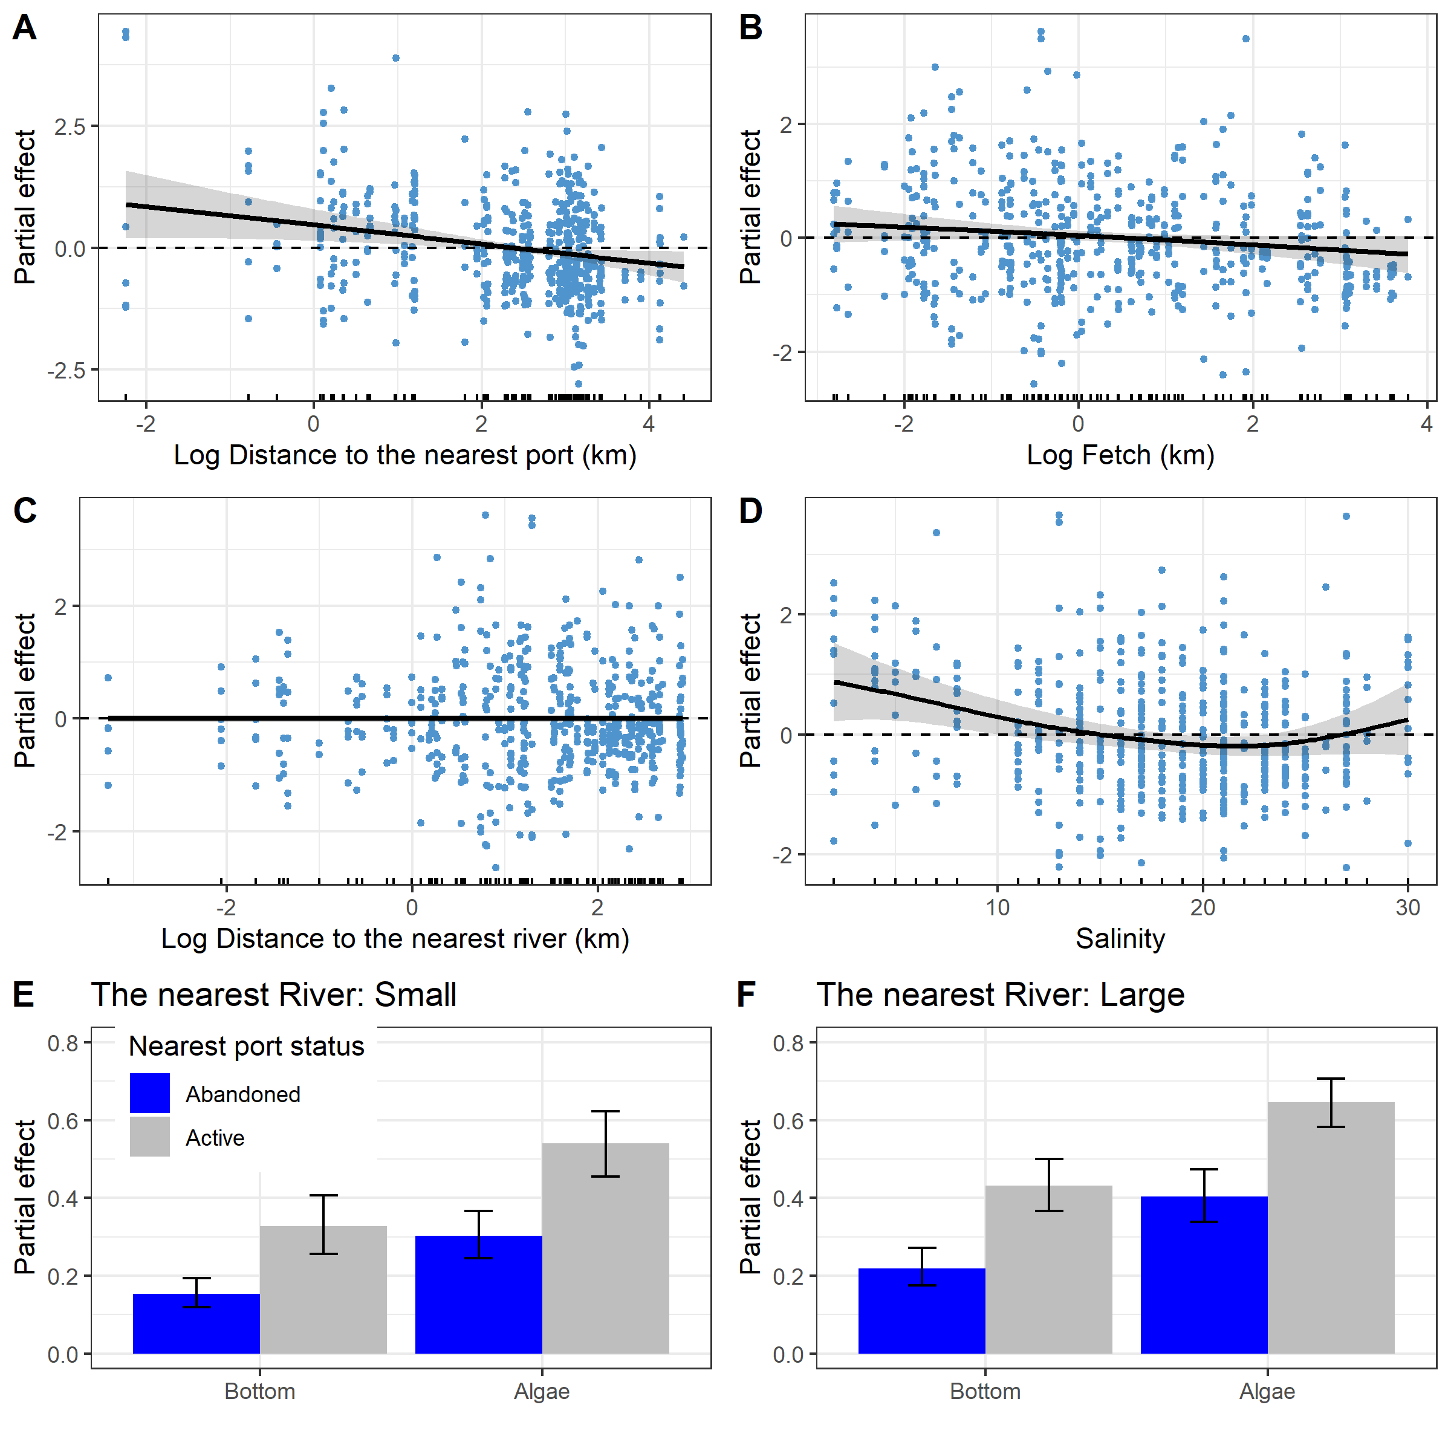
Fig. 3. Predictions of the Model 1 describing the
Емкое название для всего. Типа «partial effects of environmenlal parameters on Ptros evaluated by the model 1». A-C. Dependency of Ptros on distance to the nearest port (DistPort, A), wind exposure (Fetch, B), distance to the nearest river (DistRiver, C) and salinity at low water (Salinity, D). E-F. Расписать, что это за хуйня. Легенду продублировать на F. Сделать E и F визуально сопоставимыми. Например, красная прерывистая горизонтальная черта на уровне 0.5.
and substrate type, nearest port status and size of the largest river (E, F). The gray ribbons and wiskers demonstrate 95% confidence interval. The dotted lines in panels A-D represent the median predicted value, this value is given to track the trend in the change in model predictions. Points on panels A-D reflect partial residuals but not raw data for each sample.
According to the model, Ptros decreased both with DistPort (Fig. 3 A) and with Fetch (Fig. 3, B), i.e. proportion of MT was higher near ports and in wind-protected areas. PortStatus also had a significant effect: predicted Ptros was higher near active ports than near abandoned ones (Fig. 3 E, F). The curvilinear dependence of Ptros on salinity can be described as follows. Within the range of low to normal salinity (24 ppt in the White Sea) the predicted Ptros decreased with salinity but again increased at higher salinities (up to 30 ppt in the data) (Fig. 3, D). Further, the predicted Ptros was higher near large rivers than near small ones. Finally the value of Ptros was dramatically higher on the algal substrate than on the bottom one (Fig. 1 C,D, Fig. 3 E, F).
According to the Model 1 (Table 1, Fig. 3) Ptros has a tendency to decrease with increasing of distance to the nearest port (Fig. 1 A). The nearest port status had also significant influence on Ptros: the value was higher when port status was Active (Fig. 3 E, F). The dependency of Ptros on fetch (Fig. 3, B) was negative. No significant association between Ptros and the distance to the neares river was was found (Table 2, Fig 3 C).
The curvilinear dependence of Ptros on salinity (Fig. 3, D) can be described as follows. The predicted value of Ptros decrease when salinity moving from minimal values to apr 20-22 ppt when it reached minimum. When salinity increases after this point the Ptros value increase as well.
According to the Model 1 the value of Ptros is dramatically higher on the Algae substrate than on the Bottom one (Table 1, Fig. 3 E, F). This value is higher in those sites which is close to Active ports than to Abandoned ones. Finally, the Ptros value is slightly higher at sites situated close to Large rivers than to Small ones.
Dependency of Ptros on substrate type
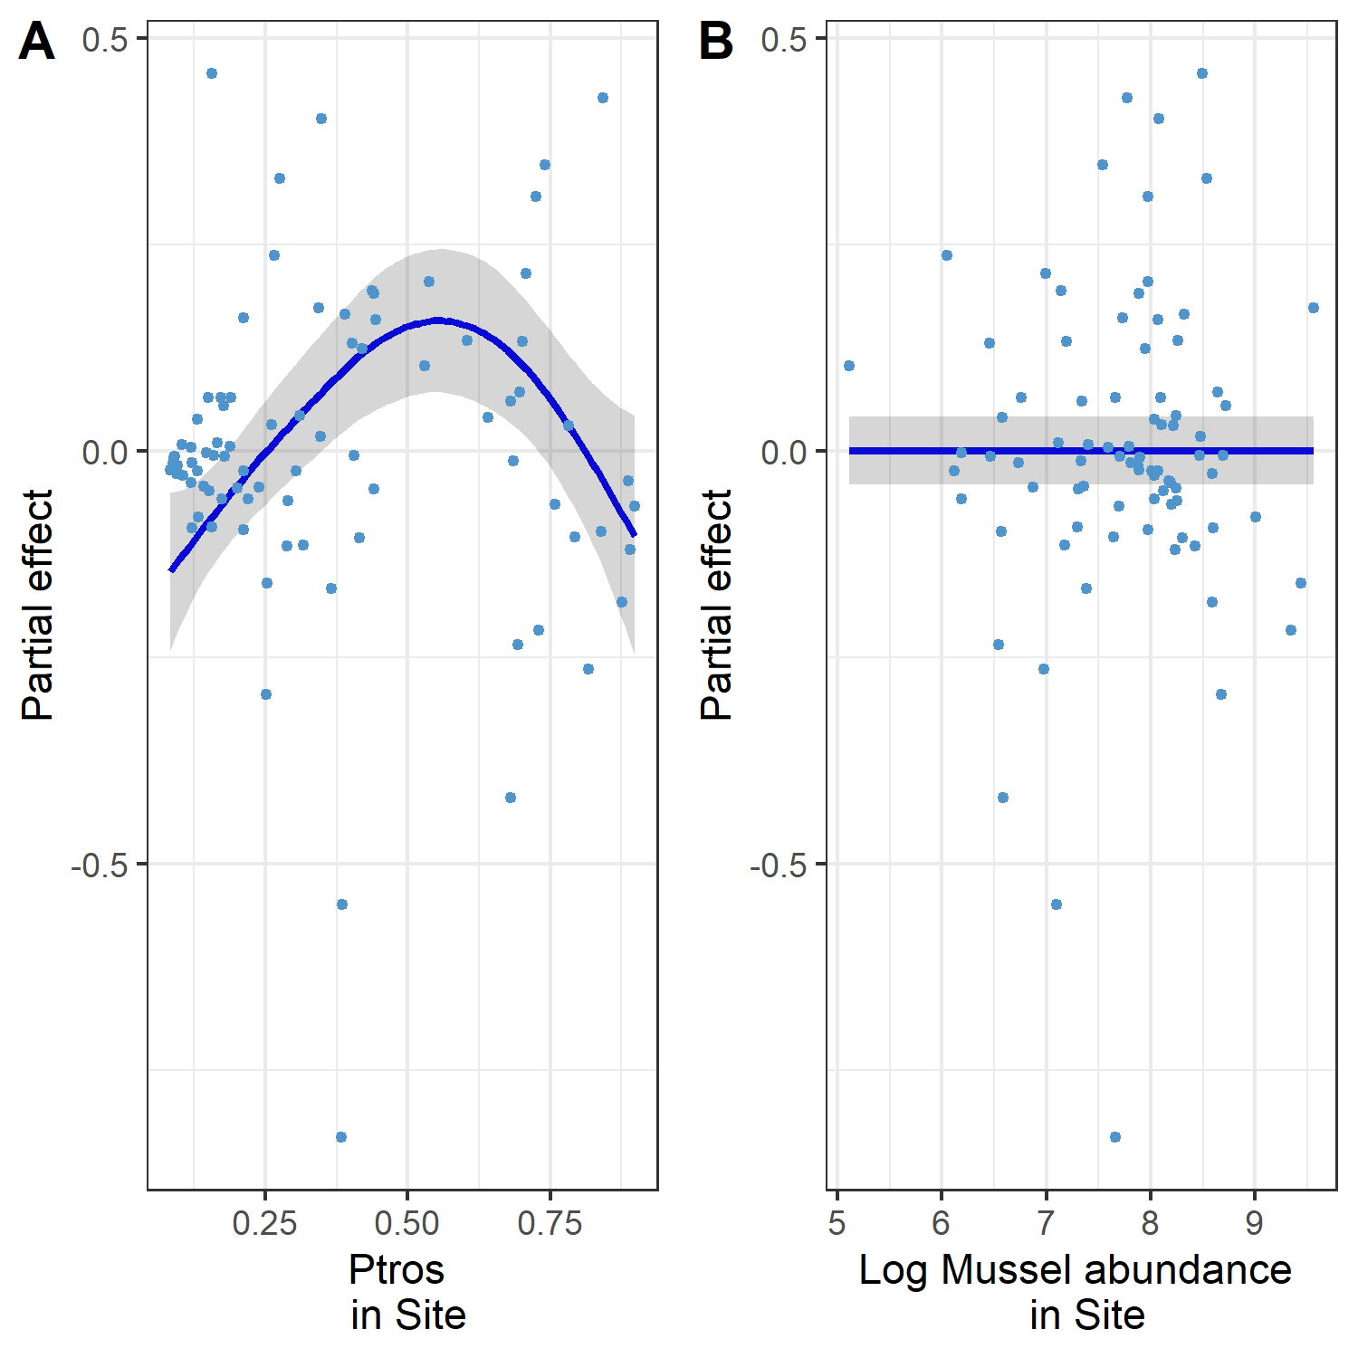
Fig. 4. The dependence of difference between PT on Algae and Bottom subatrates on Ptros_{Site} (A) and total mussel abundance in site (B).
The difference between Ptros_{Algae} and Ptros_{Bottom} substrates was significantly dependent on Ptros_{Site}, i.e. prevalence of MT (STable +, Fig. 4 A). The dependency revealed was curvelinear (edf = 2.7, STable +) with minimal Dif values in sites with minimal and maximal values of Ptros_{Site}. The maximal Dif values were associated with intermediate Ptros_{Site}. This pattern reflect the prevalence of MT at Algae substrate and prevalence of ME at Bottom substrate in those sites where both species are presented in equal amount. No significant dependency was revealed with total absolute mussel abundance (STable +, Fig. 4 B).
Parameters of the Model 2 are provided in ESM?. As expected, the dependence of diff (difference between Ptros in Algal and Bottom samples) on PtrosSite (overall Ptros in a site) was dome-shaped with minimal values in sites absolutely dominated by ME or MT (Ptros close to 0 or 1) and maximal in sites where both species were equally present. No dependency of diff on total absolute mussel abundance in a site was revealed (STable +, Fig. 4 B) indicating the lack of density dependence in segregation of species by substrate.
Assessment of model 1 predictive power
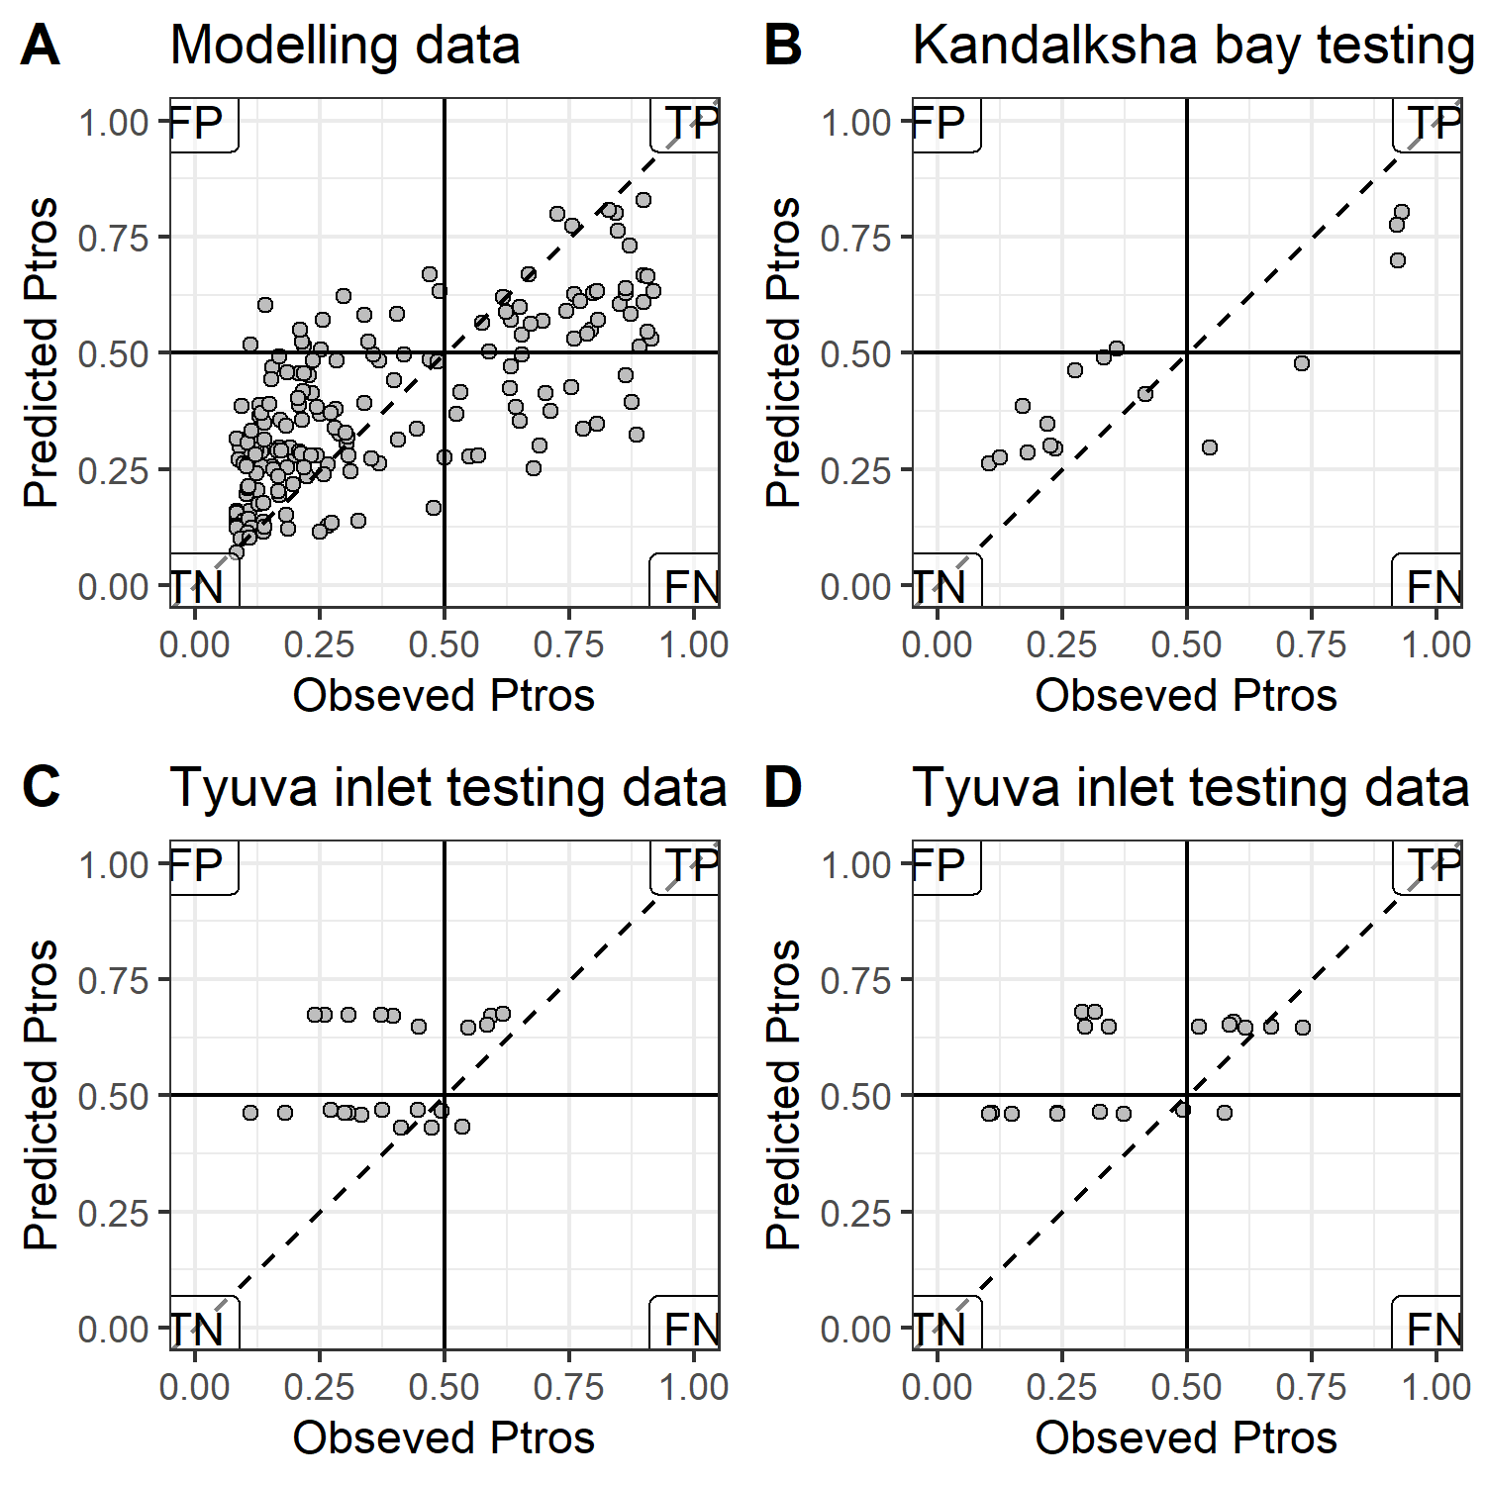
The performance of the Model 1 to predict Ptros in the modeling (A) and the testing data sets (B-D). Each plot compares empirical Ptros_site and that predicted by the model within particular data set. If the empirical and predicted values were the same, the points would lie on the diagonal (dashed line). Solid lines delineate MT- and ME-dominated sites on each axis. Labels mark the quadrants with false positive (FP), true positive (TP), true negative (TN) and false negative (FN) predictions in the analysis of the performance of the model to classify sites into ME- and MT-dominated ones. Set names are indicated in the chart headings.
Fig. 5. Comparison of Ptros-values predicted by Model 1 and obsreved Ptros for training data used for the model fitting (A), testing data from the White sea (B) and testing data from the Tyuva inlet colleced in and out of the fucoid’s belt (C and D respectively). The horizontal and vertical solid lines reflects the boundary between MT- and ME-dominated sites. Dotted lines represent the position of perfect fit when observed and predicted values are equal. Labels in the plot corners mark the quadrants with false positive (FP), true positive (TP), true negative (TN) and false negative (FN) predictions.
The Ptros values predicted by the Model 1 and observed ones (Fig. 5, A) were in rather good agreement for modelling dataset (AUC = 0.87). The most of 190 units (joined Algae and joined Bottom samples from 95) were correctly classified as MT-dominated (37 units in true positive zone) or ME-dominated (120 units in true negative zone). A few points are situated in the false positive zone (the Model 1 predicts presence MT-dominated populations, but ME - dominated ones were observed, 13 units). A part of points were presented in the false positive zone (the Model 1 predicts presence ME-dominated populations, but MT - dominated ones were observed, 19 units).
In the case of testing dataset from the Kandalaksha bay (Fig. 1 B) the most sites were correctly classified by the Model 1 (AUC = 0.84). Only 2 points were located in false negative and only 1 in false positive zone.
The performance of the model 1 to classify sites by Ptros_site into ME- and MT-dominated ones was good for “Kandalaksha littoral” testing data set (AUC=0.85 vs. AUC=0.85 for the modeling data set) with only few false negatives (i.e. sites unpredictably dominated by ME) (Fig. ? A,B). The predictive value of the model for the two testing sets from the Barents Sea was lower, although not fatally so: AUC = 0.71 for “Tyva littoral” and AUC=0.?? for “Tyuva sublittoral”. Unlike the “Kandalaksha littoral” testing set, most false results were positives (i.e., the model underestimated Ptros more often).
The Model 1 being applied to the first part of testing dataset from the Tyuva inlet (i.e. collections from fucoid’s belt) display lesser but still rather high predictive power (AUC = 0.71). Six samples were classified as false positive, but only one as false negative. The predictive power of the Model 1 being applied to the second part of the Tyuva testing dataset was similar to the previous case (AUC = 0.71). Four samples were classified as false positive and only one as false negative. In total in Tyuva data set 32 of 44 samples were correctly classified as MT-dominated of ME-dominated populations using predictions of Model 1.

Discussion
Используя беспрецедентно большой материал и статистический подход, позволяющий различать влияние потенциально коллинеарных природных факторов на мидий, мы оценили влияние солености, прибойности, близости к портам и субстрата на таксономический состав их поселений в Белом море. | Using an unprecedentedly large amount of material and SDM approach that allows us to discriminate between the effects of potentially collinear natural factors on mussels, we assessed the influence of ... on the taxonomic composition of their settlements in the White Sea.
Оказалось, что все изученные факторы по отдельности влияют на распределение видов, обеспечивая частичное расхождение их экологических ниш. По сравнению с МЕ, MT больше тяготеет к водорослевым субстратам, чем к донным, к районам портов, к местам, более защищенным от прибоя и к местам с пониженной или, напротив, аномально высокой соленостью. Некоторые из этих закономерностей были ранее известны для Кольской контактной зоны (порты, субстраты, Katolikova), некоторые предполагались или были доказаны для других контактных зон (низкая соленость, прибойность), некоторые являются полностью неожиданными (бимодальное распределение MT по солености). | It turned out that all studied factors independently influence the distribution of species, providing partial divergence of their ecological niches. Compared to ME, MT gravitates more towards algal substrates than bottom substrates, harbor areas, areas more sheltered from the surf, and areas of reduced or, conversely, abnormally high salinity. Some of these patterns were known for the Kola contact zone (ports, substrates), some were proven or postulated for other contact zones (low salinity, surf), and some are completely unexpected (bimodal distribution of MT by salinity).
Ниже мы сперва обсудим разделение экологических ниш между видами в Белом море и Кольской контактной зоне per se. Потом - насколько эти закономерности могут отражать различия в "фундаментальных" нишах видов, и проявляться в других контактных зонах. Наконец, мы обсуждаем плюсы и минусы нашего подхода к оценке разделения экологических ниш симпатрических видов и даем рекомендации по дальнейшему изучению "сообществ" видов мидий и подобных "криптических" таксонов. | Below we first discuss the division of ecological niches between species in the White Sea and the Kola contact zone per se. Then - the extent to which these patterns may reflect differences in the “fundamental” niches of species, and hence manifest themselves in other contact zones. Finally, we discuss the pros and cons of our approach to assessing sympatric species ecological niche partitioning and provide recommendations for further study of mussel species 'communities' and similar 'cryptic' taxa.
Factors of ecological segregation of ME and MT in the White Sea littoral
Harbors. Тот факт, что в Кольской контактной зоне МТ тяготеет к портам (VS 11, Katolikova 16, настоящее исследование), скорее всего, отражает историю инвазии вида в регион - морским транспортом из западной Атлантики в 20 веке, что подтверждается и генетическими данными (VS 11, Simon, Wenne ...). Католикова и др. предположили, что МТ также может быть более устойчивым к химическому антропогенному загрязнению, а также быть более оппортунистическим видом, лучше адаптированным к нарушенным местообитаниям. Наше наблюдение, что в районах закрытых гаваней частота МТ ниже, чем в районах действующих портов, не противоречит этим гипотезам. Однако следует помнить, что ныне покинутые гавани были сравнительно небольшими, что может означать более низкий уровень «propagule pressure» MT во времена инвазии, и связанную с этим исторически более низкие численности популяций инвазивного вида.  Surf. Ожидаемый результат с учетом того, что у МТ более хрупкие (и легкие) раковины, которые могут ломаться от прибоя.  Salinity. Низкая соленость ожидаемый результат, помятуя о Балтике (подробнее см. ниже). Высокая, напротив, неожиданный. Или апвеллинг и нарушенные местообитания. Ии, скорее, лажа с язычками (упомянуть, что в Тюве специально учитывали).  Substrates. Я не знаю, на что сослаться на счет биссуса, но на католикову – что это какой-то shock absorber и что когда ты легкий тебе легче жить на фукусе. Про плотность я ничего не понял. Возможно доказывает что оба в равной степени могут там жить, причем всегда расходятся.  White Sea vs. Barents Sea data sets. Сказать, что приемлемо, хотя и хуже, причем за счет недоучета МТ, особенно в сублиторали. Валить на плохую классификацию фукус-грунт, на неочевидность, что ламинарии это фукусы (требует проверки) и что глубина, которая сильно варьировала для сублиторали, как известно, имеет значение.  Cryptic factors. Глубина, звезды с куликами, хз что еще. Пообещать в следующий раз. | Harbors. The fact that in the Kola contact zone MT gravitates towards ports (VS 11, Katolikova 16, present study) most likely reflects the species' history of invasion into the region - by sea transport from the western Atlantic in the 20th century, which is also supported by genetic data (VS 11, Simon, Wenne ...). Katolikova et al. 2016 suggested that MT may also be more resistant to anthropogenic chemical pollution and generally be a more opportunistic species, better adapted to disturbed habitats. Our observation that MT frequency is lower near abandoned harbors than near active harbors is consistent with this hypothesis. It should be remembered, however, that the now abandoned harbors were comparatively small, which may mean the historically lower propagule pressure of MT at the time of the invasion, and thus its smaller population sizes in the long term.  Surf.
Ecological niche portioning between MT and ME in the Kola contact zone vs. other contact zones.
МЕ и МТ представляет собой непростую модель для изучения расхождения экологических ниш близких видов в симпатрии, что связано с их широким распространением, гибридизацией и биогеографической историей. МЕ и МТ достаточно старые виды (3.5 миллионов лет дивергенции), эволюционировавшие в аллопатрии а северной Атлантике и северной Пацифике, соответственно (). В своих родных океанах они играют схожие экологические роли () и потому исходно могут/должны иметь сильно перекрывающиеся экологические ниши. Контактные зоны между видами в разных углах Атлантики сформировались в результате разновременных инвазий МТ из Тихого океана, а также внутри самой Атлантики (). Разные зоны можно рассматривать как разные экологические (и эволюционные) эксперименты, поставленные в разных природных условиях (от Балтики до Шпицбергена), в разное время (от позднего послеледниковья до исторического периода, см. ссылки выше) и, возможно, с разным «дизайном» в том смысле, что в одних зонах первопоселенцем мог быть один вид, а в других - другой. Сверх этого, на расхождение их экологических ниш в симпатрии, помимо конкуренции (“character displacement”, ), могли влиять гибридизация (“reinforcement of prezygotic reproductive isolation”, ) и интрогрессия (transfer of adaptations, etc. REF). Все это наводит на мысль, что разные зоны должны различаться, и это было лейтмотивом ряда генетических исследований (). Это, однако, не отменяет того, что различия между видами являются наиболее фундаментальными, и это должно отражаться в сходстве их экологических фенотипов в разных зонах.  Важный результат нашего исследования - демонстрация, что частота МТ повышена в местообитаниях с низкой соленостью не только в Балтийском море. Это, как кажется, разрешает старинную интригу о контрастных соленостных адаптациях балтийской MT и всех остальных популяций этого вида (e.g. RC 05, Katolikova, VS11). То, что связь с соленостью раньше не могли разглядеть на ограниченном материале из Белого моря, очевидно, связано с пространственным масштабом соленостных градиентов (локальные vs. geographical in the Baltics), относительно узком диапазоном соленостной изменчивости в местах обитания мидий, и с наличием множества других факторов, влияющих на распределение видов в Белом море.  Кроме того, выявить корреляцию могла мешать загадочная бимодальность в распределении МТ относительно солености (которая может быть ложной закономерностью, см. выше).  Скорее всего, аналогичная связь с низкой соленостью есть и в других контактных зонах. Так, например, повышенную частоту МТ неоднократно отмечали в опресненных и затишных районах - в Норвегии (), Шотландии (), Гренландии (), ... .  Данные по прибойности очень противоречивы …  по поводу surf какую-то хуйню написал. «Two wave-exposed sites had the highest frequency (>90%) of M. trossulus» - Bates, J.A., Innes, D.J. Genetic variation among populations of Mytilus spp. in eastern Newfoundland. Marine Biology 124, 417–424 (1995). https://doi.org/10.1007/BF00363915...  По поводу фукусов нечего сказать – изучать надо, | ME and MT represent a challenging model for studying the divergence of ecological niches of closely related species in sympatry due to their wide distribution, hybridization and biogeographic history. ME and MT are quite old species (3.5 million years of divergence), having evolved in allopatry in the North Atlantic and North Pacific, respectively (). They play similar ecological roles in their native oceans () and therefore may initially have strongly overlapping ecological niches. A set of geographically disconnected contact zones between MT and ME have formed as a result of repeated MT invasions from the Pacific and also within the Atlantic (). Different zones can be seen as different ecological (and evolutionary) experiments, set in very different environments (from the Baltic to Svalbard), at different times (from the late post-glacial to the historical period, see references above) and possibly with different “design” in the sense that in some zones one species may have been the original settler and in others another. In addition to competition (“character displacement”, ), hybridization (“reinforcement of prezygotic reproductive isolation”, ) and introgression (transfer of adaptations, etc. REF) between species could influence the divergence of their ecological niches in sympatry. All this suggests that different zones should differ, and this hypothesis has been a leitmotif of some genetic research (RC, Simon et al. … ). This, however, does not negate the fact that differences between species must be fundamental, and this should be reflected in the similarity of their ecological phenotypes in different zones.  An important result of our study is the demonstration that MT frequency is elevated in low salinity habitats not only in the Baltic Sea. This seems to resolve the old intrigue about contrasting salinity adaptations of the Baltic MT and all other populations of this species (e.g. RC 05, Katolikova, VS11). The fact that the relationship with salinity could not be discerned earlier on the limited material from the White Sea is obviously due to the spatial scale of salinity gradients (local vs. geographical in the Baltics), the relatively narrow range of salinity variability in mussel habitats, and the presence of many other factors affecting species distribution in the White Sea.  In addition, the puzzling bimodality in the distribution of MTs with respect to salinity (and which may be a spurious pattern, see above) may have prevented the correlation from being detected.  Most likely, there is a similar relationship with low salinity in other contact zones. For example, increased frequency of MTs has been repeatedly observed in desalinated and storm protected areas - in Norway (), Scotland (), Greenland (), .... .
Подход лучше традиционного – кореляционного – но не позволяет оценить долю изменчивости, объясняемой изученными факторами вместе и по отдельности, а также их совместным влиянием.
Чтобы изучить, например, глубину – надо все переделывать?
Почему иные не берут кривизну?
Ты не напиздел про соленость?
Идеальная схема? Эта что-ли?

Processing a large number of samples from various sites across a wide range of environmental conditions in the Kandalaksha Bay contact zone, we developed the Model 1. This model can be considered both as SDM describing the association with environmental predictors and JSDM reflecting the joint distribution of the two mussel species, Mytilus edulis and M. trossulus. It is important to acknowledge that the model we have constructed represents only one of the initial efforts to characterize the relationship between cryptic mussel species and their environment. Similar to previous studies by Kijewsky et al.(+++) and Winne et al. (+++), our analysis focused on the distribution of mussels in their contact zones exclusively. The broader pattern of species distributions, including their relationships with various factors across the entire range of the cryptic species, falls outside the scope of this study. Nevertheless, the most significant events related to species interactions with environmental factors and with each other (including intraspecific relationships) occur primarily in contact zones.
The set of environmental predictors included in the Model 1 obtained most of those factors that were generally considered as the important regulators of the taxonomic structure of mussel’s populations in MT-ME contact zones (+++++). Being included in one SDM these factors possessed significant influence on Ptros (i.e. proportion of MT ). Thus, our analysis provided the consistent evidence that factors such as salinity, proximity to ports, level of surf and substrate type influence the taxonomic composition of mixed mussel populations. In addition, we found that the predictors included in the model are not collinear. This means that we can consider all these factors as relatively independent ecological axis that do not mask each other, which is important for SDM construction (De Marco and Nobrega, 2011). In addition we considered environment variation in a relatively small contact zone in the Kandalaksha Bay. We can state that the patterns revealed on more extensive contact zones (e.g. in the Baltic - North Sea contact zone, see Kijewsky et al, 2019) with longer ecological gradients retain their influence in essentially smaller spatial scales. This fact allow to optimistically expect the ability to construct working SDM describing distribution of MT and ME in contact zones of different sizes.

The SDMs are frequently considered as models reflecting structure of species’ ecological niche (Elith, Leathwick, 2009). Although the very concept of ‘niche’ is under the criticism (McInerny, Etienne, 2012 a,b,c) analysing the relationship of cryptic species to environmental factors and investigation of mechanismes of their distribution along environmental gradients is undoubtedly an important task. In this sense, any statistically significant association of Ptros with some environmental predictor would reflect the divergence of MT and ME in ecological space (i.e. partitioning of niches).

From all environmental variables included into analysis the distance to the nearest port and its status (Abandoned VS Active) may have dual interpretation. We revealed higher MT proportion close to active ports. On the one hand, active ports tend to have a higher degree of anthropogenic pollution, leading to stress of mussels (Hellou & Law, 2003). Different mussel species are known to interact differently with pollutants (Beyer et al., 2017). For example, in the Halifax area MT are more abundant in the most polluted habitats than ME, but show less stress tolerance than ME (Hellou & Law, 2003).
Another explanation may be that there is some foci of disease associated with port areas that affect MT and ME diferently. For example we can look for the reason in such infections as the bivalve transmittable neoplasia which is associated with harbors (Hammel et al., 2023) or in other parasite diseases for which ports are hot-spots for invasion (Feis et al., 2019). This could be a perspective direction in future attempts to construct more reliable SDM.
From the other hand the dependency of Ptros on distance to the nearest port and its status can reflect not true axis in ecological space but some trace of historical processes. It is believed that MT was introduced into the Barents and the White Seas due to ship traffic during World War II (Vainola & Strelkov, 2011). This hypothesis was based primarily on the fact that high concentrations of MT were found in the vicinity of currently active or abandoned ports in the region (Vainola & Strelkov, 2011; Katolikova et al. 2016). The results of our study are inline with this hypothesis. The Ptros value increased with approaching to harbors in the studied area. Apparently, the degree of port activity also plays an important role. According to our data, if the port nearest to the mixed settlement is active, i.e. it serves the ships coming from outside the White Sea (in our case it is “Kandlaksha” and “Vitino” ports), then the Ptros value in such settlements is higher than in the settlements adjacent to the abandoned harbors. The observed relationship may be related to the fact that the currently active ports were the largest and most economically sustainable systems in the region. This may be based on the higher shipping traffic, which has led to a more massive invasion of MT from other regions (primarily from the ports of Murmansk in the Kola Bay, where the abundance of MT is high, Vainola&Strelrov, 2013; Marchenko et al., 2023). In the abandoned ports, the introduction of the alien species occurred during the times of their active operation. However, during several decades of inactivity of abandoned ports MT could be displaced by native ME.
In any case, our data are in line with earlier stated hypothesis that in the case of the White Sea MT is an invasive species (Vainola&Strelkov 2011). Unfortunately, only few data could be provided to check this hypothesis for other European MT -ME populations. However the ship traffic was successfully included into SDMs describing invasive species in European waters (Lindegren et al., 2022) this factor was never included into models describing MT-ME distribution previously. In some cases it is probably an unrealistic aim due to absence of predictor variability. For example in the case of MT-ME populations in the Baltic Sea, where there is extremely active ship traffic and vessels visiting almost all parts of the Baltic Sea, it is not possible to identify a correlation between the distribution of MT and the presence of ports. At the same time, if we look at the more broad map of MT distribution (Vainola & Strelkov, 2011) around European coasts, the confinement of MT to large European ports out of the Baltic Sea (e.g. Bergen, Murmansk), rather speaks in favor of the hypothesis of MT introduction due to ship traffic. Thus, while proximity to ports is not an environmental factor in a direct sense, it is a parameter that should be kept in mind when building a more general SDM describing MT-ME distribution in contact zones.
Our analysis revealed that the higher wind fetch is associated with lower Ptros. That means MT avoid open coasts potentially exposed to the surf. The lowest Ptros was observed on open shores of the north-east coast of Kandalaksha Bay (Fig. 1 A), exposed to wave action due to southeast and south-west winds which are frequent in the White Sea region (Berger, Naumov, 2001). This result corresponds well with the data on the thickness of MT and ME shells. It is known that MT have thinner, more fragile shells (Beaumont et al., 2008; Michalek et al, 2021; our unpublished observations of mussels from the White Sea are in line with this data). It is logical to expect that mollusks with such characteristics should avoid places with high wave loading. In such habitats, ME with stronger shells are expected to benefit. A similar pattern can be seen in other contact zones. For example, in Greenland, an increased frequency of MT was noted at the sheltered top of the fjord (GLS and GLD sites, Fig. 1 in Wenne et al. 2016), while the population at a more open site located near fjord mouth (GLL site in Wenne et al. 2016) is dominated by ME. We believe that when building a more general SDM, based on the study of many contact zones, it is necessary to take into account this environmental parameter. It is possible that some more reliable way to estimate the degree of wave impact will be proposed, but fetch has already been shown as a convenient parameter on which mussel settlement characteristics depend (LaBarre et al., 2023).
The nature of the substrate was discovered as the powerful predictor regulating Ptros variation in the scale of several meters. The Ptros appears to be significantly higher on algal than on bottom substrates (silty-sandy sediment, pebbles, boulders and rock surfaces) located in close proximity (not more than 20 m, within the same fucoid belt). This pattern was first detected in the analysis of a significantly smaller volume of material (Katolikova et al., 2016). Bringing in new data collected in a wider range of conditions confirmed the presence of this pattern.
However, a closer examination of the relationship with substrate type (Fig. 4 A) showed that the maximum Ptros divergence between Algae and Bottom substrates occurred only when both mussel species were present in approximately equal numbers at a given location. This could be interpreted as divergence of realized niches as a result of interspecific competition. This, however, is contradicted by the lack of correlation of Dif-value with the absolute abundance of mussels at the site. If the mentioned divergence of realized niches were a consequence of competition, one would expect that the strength of this interaction would increase with increasing settlement density, which is not observed. Thus another explanation should be considered.
As possible explanation we can propose some difference in byssus attachment strength. Perhaps MT are capable of attaching to underwater substrates more strongly than ME do. This should cause less strongly attached molluscs to break off and remain on the bottom under constant fluctuations of fucoid’s thallus. Additional investigations of attachment strength of both species are needed.
The divergence of the two species by substrate is undoubtedly significant evidence of ecological niche partitioning between creyptic species, but the value of substrate type as an SDM parameter for predicting the conditions under which an increased concentration of a species can be expected in mixed settlements may not be as high. Austin (2002) considers two types of environmental gradients: distal and proximal ones. The proximal gradient is a causal environmental variable determining the direct organism response. The response to distal gradients is mediated by a longer chain of reactions. For example, fetch or proximity to ports has no direct effect on mussel viability and they should be considered as distal gradients. Whereas can a mussel attach itself to the present substrate in given location seems to be dependent primarily on substrate type. In this sense the later should be classified as proximal gradient. Since it is very difficult to provide GIS coverage for proximal variables their value for predictive mapping of species distribution probably impractical (Austin, 2002). However the type of substrate from which mussels were collected should be obviously registered during the sampling session.
An intriguing result of our study was the absence of clear linear dependency between taxonomic structure of mixed populations and salinity that was revealed in other contact zones (Kijewsky, 2019). However, surprisingly, in spite of the fact that salinity is considered as a leading factor at least in Baltic contact zone only a few works have been devoted to comparison of ecophysiological responses of MT and ME to salinity (Gardner&Thompson 2001; Qiu et al., 2002; Knobel et al. 2021). Moreover, the direct physiological investigations did not reveal unequivocal evidence that adult MT are better adapted to reduced salinity than adult ME (Gardner&Thompson 2001; Qiu et al., 2002). It has only been shown that larval stages of MT survive lower salinity better than the same ME stages (Qiu et al., 2002). That is the prevalence of MT in lower salinity could be explained by early selective pressure during passive larval drift across salinity gradient (Knobel et al. 2021).
In our investigation the GAM fitted reveal a statistically significant curvelinear (close to U-shape) relationship of Ptros to directly measured salinity. From one hand, our Model 1 revealed higher Ptros in lower salinity which is typical for Baltic contact zone. On the other hand, Ptros was inflated when salinity was high. We can propose three explanation to this fact.
Firstly, although directly measured salinity seems to be a natural ecological factor, this may not be the case for littoral mussel settlements. The salinity levels significantly vary during the tidal cycle and the range of the variation is highly dependent on the distance from the fresh water source (Attrill, 2002; Marchenko et al., 2023). We do not know which salinity is more important for littoral mussels living in the estuaries: high during the ebb time or reduced in the low tide. Further, the salinity measured once during the sampling process may occasionally be anomalously low or high by accident (e.g. due to precipitation or upwelling of deep salted water, respectively). If this explanation is correct, then the observed increase in Ptros at high salinity may be a consequence of incorrect estimates of the salinity regime..
A second explanation for the Ptros peak in high salinity sites may be related to the lower reliability of the morphotype-test for species identification under high salinity conditions. Khaitov et al (2021) suggested that in cold Arctic waters with high salinity, ME more often exhibit T-morphotype, which reduces the sensitivity of the method. However this is contradicted by the fact that in the same locations where high salinity and high Ptros values were detected (e.g. in the Umba area, Fig. 1 A, B) genetic analysis of mussel populations revealed an increased frequency of MT genes (Katolikova et al.2016).
–>
And finally, it should be noted that sites with high Ptros and low (<15 ppt) or high (>27 ppt) salinity are not numerous (compare concentration of points in Fig ++, D). In locations, where salinity is intermediate, Ptros does not differ significantly from the background value. That is, anomalously high Ptros values are observed in some marginal habitats. Such pattern can be expected if we assume that MT is a weaker competitor, which on average cannot displace ME. This assumption is supported by the fact that the settlements that we classify as MT-dominated are essentially scarcer in the studied area (TP + FN part of the Fig. 5 A) than the ME-dominated sites (FP + TN part of the Fig. 5 A). The roughly U-shape association between Ptros and salinity can be turned into bell-like dependency of proportion of ME on salinity. This means that the majority of mussels presented in the sites within intermediate salinity range are mostly ME. Such displacement of weaker competitor into marginal habitat is well known for other systems where inviders met resident species: mosquito larvae (Juliano, 1998), fishes(Herbold, Moyle, 1986) and geckos (Case et al 1994). Usually resident species persist in their optimal habitats if they have not been destroyed but introduced species prevail in marginal habitats (Juliano, 1998). To note, actively used harbors appear to be the very marginal habitats as well.
In any case, we should not ignore the role of salinity in regulating of taxonomic composition of mixed population when constructing SDMs. The general desalination regime in the contact zone should also probably be taken into account. For example, in our case, higher MT concentrations were observed when the nearest river was a Large one. The relationship with the status of the nearest river can be explained not only by the fact that a large river can be a powerful source of desalination. It may be a consequence of the fact that in the immediate vicinity of large rivers there may be areas of MT concentration. These refugiums could serving as a source of larvae of MT for the surrounding regions.
The strongest argument that the constructed model is useful is its ability to predict phenomena on the dataset that was not used to build the model. We used two testing datasets. One was represented by material collected in the same area as the training samples (Fig. 5 B). The ROC-analysis showed that Model 1 has a high ability to predict the assignment of the sample to one of the two categories MT-dominated vs ME-dominated. The AUC-values calculated for both modelling and testing data sets from the White Sea were higher than useful amount of discrimination, empiricaly assessed as AUC >0.75 (Elith et al., 2006).
When the Model 1 was used for predictions in a different region, the Tyuva inlet, where an independent contact zone is presented, the quality of the prediction decreased. However, the AUC values were close to the above threshold and were well within the average predictive power values for GAM as a method of SDM constructing (Elith et al., 2006). At the same time, it should be kept in mind that a key predictor such as substrate type was estimated very roughly when analyzing this dataset. This may have reduced the predictive power of the model. In addition, it should be taken into account that Tyuva Bay is located in a different climatic zone than the White Sea and differences in, for example, temperature regime may be affected. We have not included predictors with latitudinal variation in the Model 1. Perhaps in the future, when building a more universal SDM, some factors with latitudinal variation (e.g. temperature, precipitation, etc.) should be included.
The important result of the Model 1 applying was the high number of false positive predictions in the case of the Tyuva inlet. There may be some ecological reasons for this pattern. If a suitable habitat is not colonized by a target species which population is small (i.e. the area is not saturated) or the population is collapsed due to displacement as a result of inter-specific competition, all this reasons could produce false positive result when a model-classifier is applied (Fielding & Bell, 1997). Indeed the MT population in the Tyuva inlet displayed pronounced decreasing associated with increased ME population (Marchenko et al 2023). We may expect the Tyuva inlet conditions are highly suitable for MT population but once appeared it demonstrated decrease probably due to competitive displacement by ME.
We expect that alternative scenario may take place in the case of the Kandalaksha Bay. Let’s remember that false negative predictions were rather frequent in the area, i.e. MT-dominated populations are frequently present in unsuitable conditions. This could be interpreted as evidence of the oversaturation of the region by MT-populations. This may be observed during mass invasion of the species into new habitats.

Conclusion
In our analysis, we did not aim to construct some perfect SDM it is the task for further investigation when information on different contact zones would be combined. That is why we did not try to build some final model (for example, by procedure of backward selection of optimal predictors’ set) and did not try to find the most appropriate modelling method (see Elith et al 2006). It was important for us to understand whether in principle a working model can be built based on those predictors that have come to the attention of researchers studying contact zones of cryptic mussel species. Our results are optimistic about this possibility but since the contact zones between MT and ME are scattered over a very wide range of latitudes and situated in various biotic surroundings the appropriate form of the “general” model should be well considered. It is obvious that some additional predictors (e. g. temperature or its correlates, the position in the intertidal-subtidal gradient, etc) should be included in a future model. It is also clear that the “general” model should include some biotic interactions (see Wisz et al 2013) and be developed within the JSDM framework (see Ovaskainen & Abrego, 2021 for a theory). The dependent part of this model should include not only proportions of two coexisting mussel species but a matrix describing the community where mussel’s species coexist with other species. Our study has shown that algae play an important role in the local distribution of species. Perhaps the spatial variation in algae abundance (and probably algae species composition) can play a significant role in the distribution of the cryptic mussel species. Thus algae characteristics in region should be somehow incorporated in the model. Perhaps some role may also be played by predators, which can regulate the proportion of mussel species (Khaitov et al.2018; Khaitov et al.2023 ). However the first step to construct the working SDM is the deep comparison of ecological features of different MT-ME contact zones. It may be that the different contact zones are not as disparate as previously thought (RC 2005 ++++).

Literature cited
Лоция Белого моря / Гидрографическое управление ; общ. ред. А. Н. Рождественского. – 5-е изд. – Ленинград : Издание Гидрографического управления, 1932. – LXXII, 566 с., 22 вкл. л. ил., карт., схем.

Supplementary electronic materials (SEM)
–>
–>

